SupersetId-6419073
WEEK 7 - REACT
9.ReactJS-HOL
React Application named “cricketapp”
(i)Project setup
npx create-react-app cricketapp
cd cricketapp
(ii)Folder structure
src/
├── components/
│ ├── IndianPlayers.js
│ └── ListOfPlayers.js
├── App.js
├── index.js
ListOfPlayers.js
// src/components/ListOfPlayers.js
import React from 'react';
const players = [
{ name: 'Rohit Sharma', score: 95 },
{ name: 'Virat Kohli', score: 88 },
{ name: 'Shubman Gill', score: 45 },
{ name: 'Ravindra Jadeja', score: 65 },
{ name: 'Jasprit Bumrah', score: 30 },
{ name: 'KL Rahul', score: 78 },
{ name: 'Hardik Pandya', score: 84 },
{ name: 'Mohammed Shami', score: 25 },
{ name: 'Surya Kumar', score: 90 },
{ name: 'Ishan Kishan', score: 70 },
{ name: 'Yuzvendra Chahal', score: 55 }
];
// Filtering below 70 using arrow function
const lowScorers = players.filter(p => p.score < 70);
export default function ListOfPlayers() {
return (
<div>
<h2>All Players</h2>
<ul>
{players.map((player, i) => (
<li key={i}>
{player.name} — Score: {player.score}
</li>
))}
</ul>
<h3>Players with Score Below 70</h3>
<ul>
{lowScorers.map((player, i) => (
<li key={i}>
{player.name} — Score: {player.score}
</li>
))}
</ul>
</div>
);
}

IndianPlayers.js
// src/components/IndianPlayers.js
import React from 'react';
export default function IndianPlayers() {
const team = [
'Rohit', 'Virat', 'Gill', 'Jadeja', 'Bumrah', 'Rahul', 'Hardik', 'Shami'
];
// Destructure odd & even players
const oddTeam = team.filter((_, i) => i % 2 === 0);
const evenTeam = team.filter((_, i) => i % 2 !== 0);
// Merged T20 and Ranji players using ES6 spread
const T20 = ['Iyer', 'Pant', 'Surya'];
const Ranji = ['Pujara', 'Saha'];
const merged = [...T20, ...Ranji];
return (
<div>
<h2>Odd Team Players</h2>
<ul>
{oddTeam.map((p, i) => <li key={i}>{p}</li>)}
</ul>
<h2>Even Team Players</h2>
<ul>
{evenTeam.map((p, i) => <li key={i}>{p}</li>)}
</ul>
<h2>Merged T20 + Ranji Players</h2>
<ul>
{merged.map((p, i) => <li key={i}>{p}</li>)}
</ul>
</div>
);
}

App.js
// src/App.js
import React from 'react';
import ListOfPlayers from './components/ListOfPlayers';
import IndianPlayers from './components/IndianPlayers';
function App() {
const flag = true;
return (
<div style={{ padding: '20px' }}>
<h1>Cricket App 🏏</h1>
{flag ? <ListOfPlayers /> : <IndianPlayers />}
</div>
);
}
export default App;
(iii)Run the app
npm start

OUTPUT:
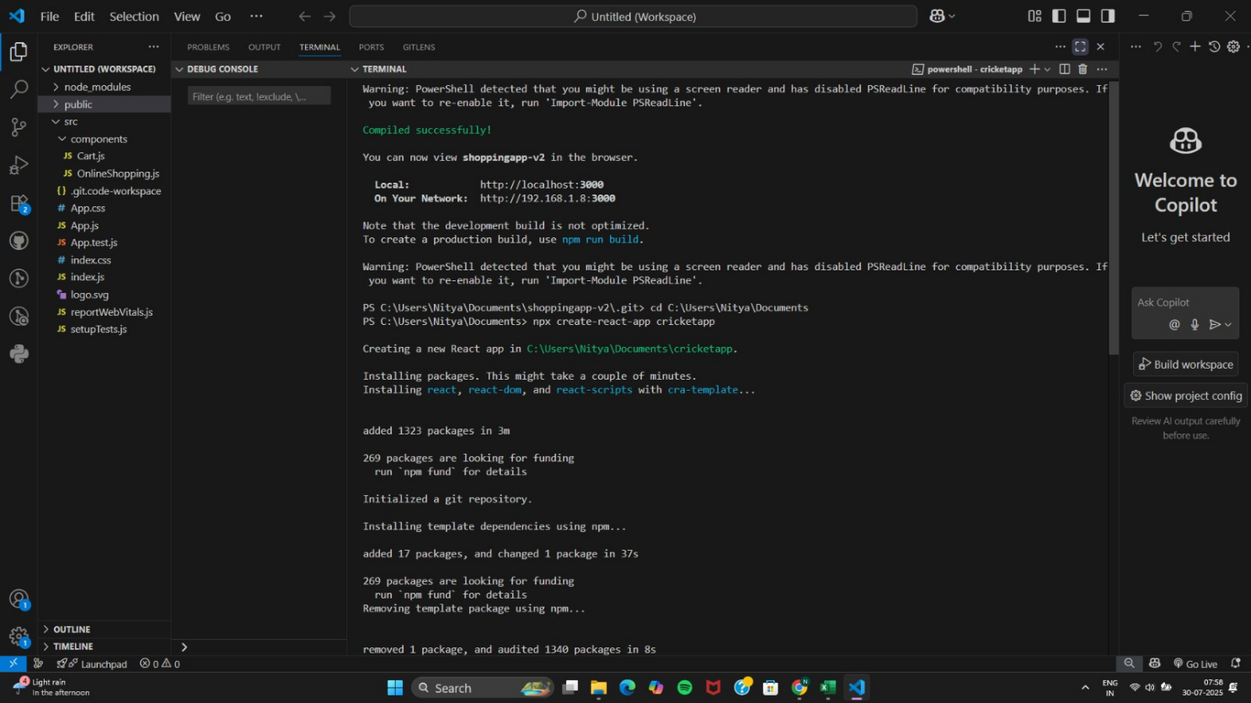
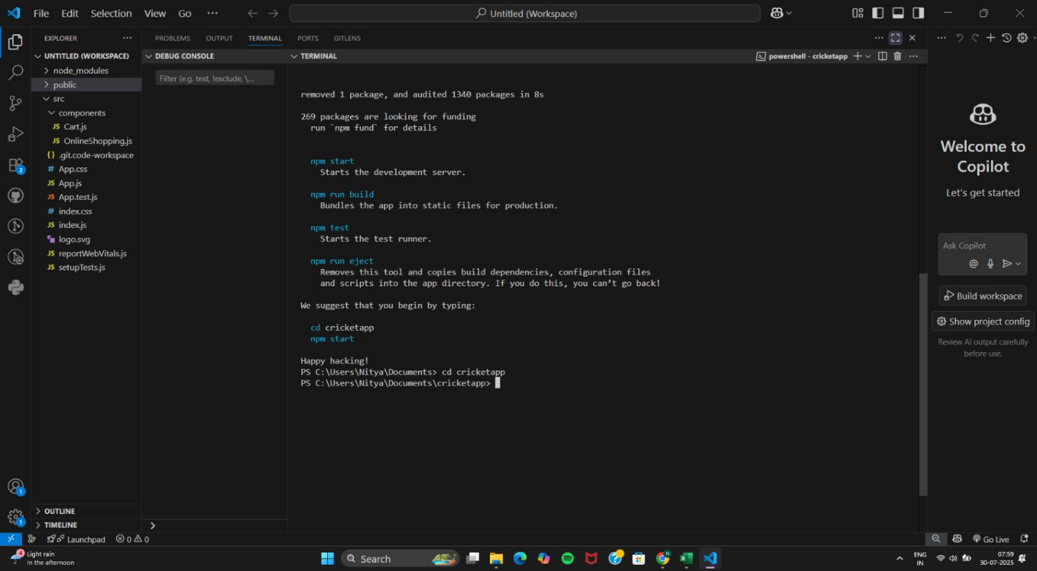
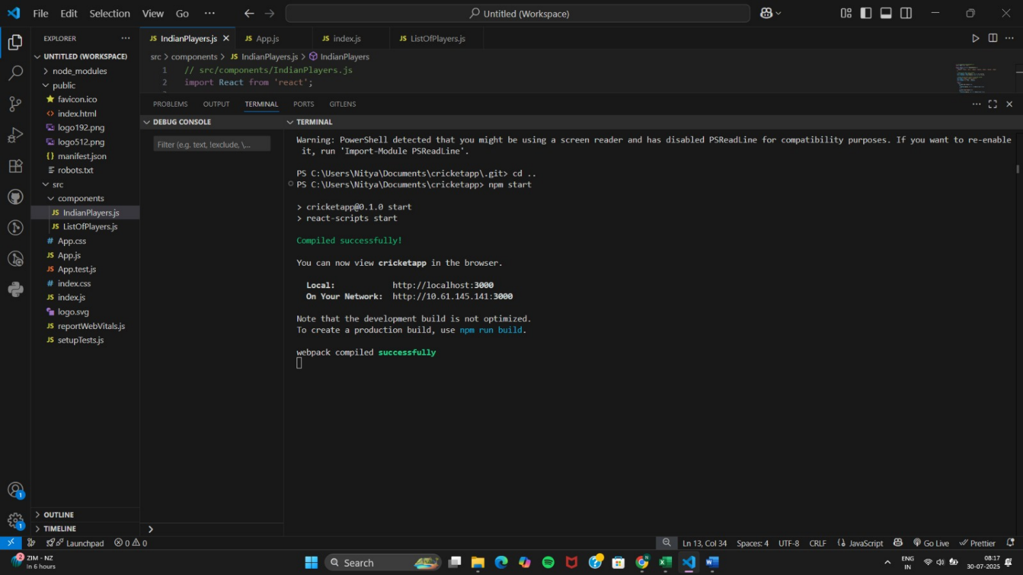

http://localhost:3000
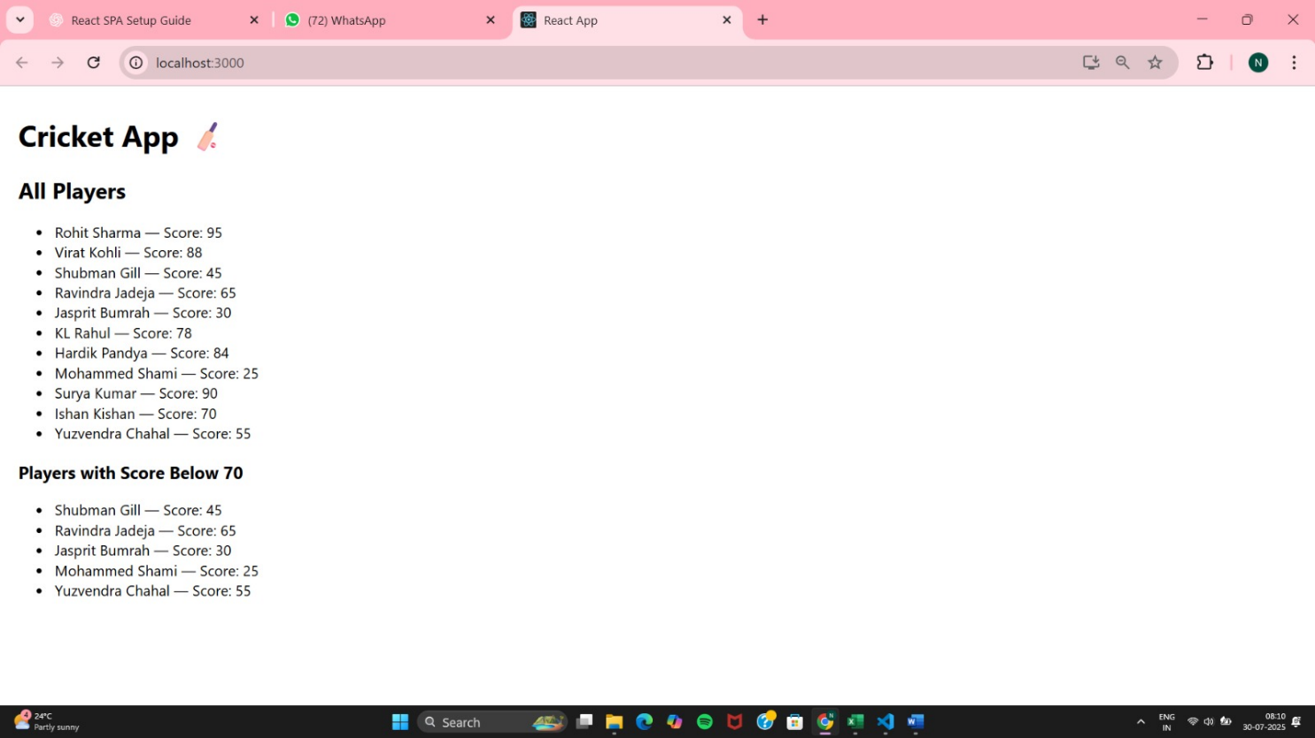

App.js (flag = false) :
import React from 'react';
import ListOfPlayers from './components/ListOfPlayers';
import IndianPlayers from './components/IndianPlayers';
function App() {
const flag = false;
return (
<div style={{ padding: '20px' }}>
<h1>Cricket App 🏏</h1>
{flag ? <ListOfPlayers /> : <IndianPlayers />}
</div>
);
}
Output:
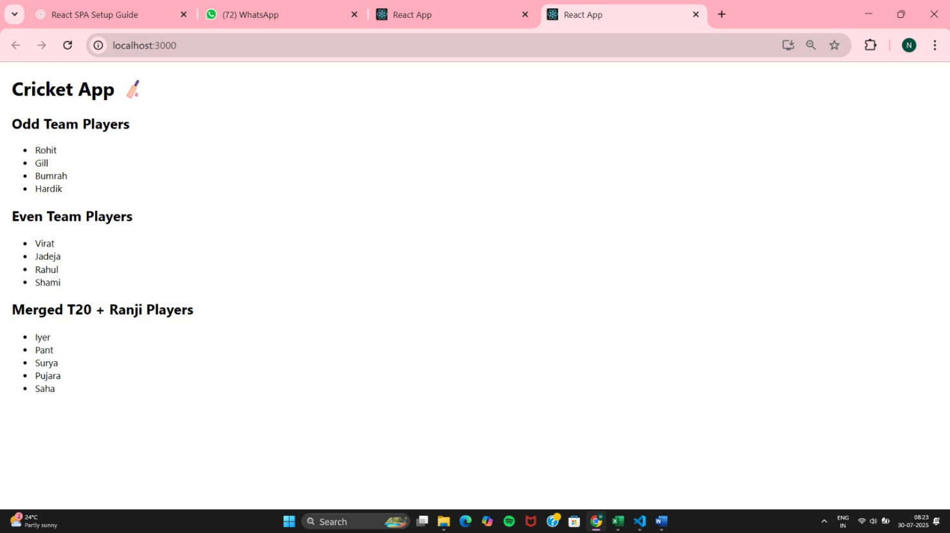

10. ReactJS-HOL
React Application named “officespacerentalapp” which uses React JSX to create elements, attributes and renders DOM to display the page.

(i)Project setup
npx create-react-app officespacerentalapp
cd officespacerentalapp

(ii)Project Structure
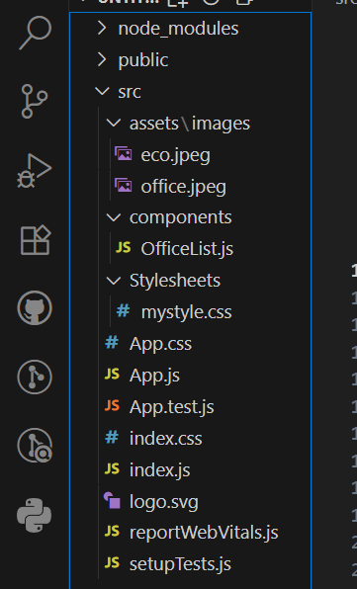
OfficeList.js
// src/Components/OfficeList.js
import React from "react";
import office from "../assets/images/office.jpeg";
import eco from "../assets/images/eco.jpeg";
import "../Stylesheets/mystyle.css";
const OfficeList = () => {
// Sample office data
const offices = [
{
id: 1,
name: "Skyline Tower",
rent: 55000,
address: "12th Street, Downtown",
image:
"https://images.unsplash.com/photo-1505691938895-1758d7feb511?auto=format&fit=crop&w=600&q=80",
},
{
id: 2,
name: "TechHub Plaza",
rent: 72000,
address: "45th Avenue, Silicon Park",
image: office,
},
{
id: 3,
name: "GreenSpace Offices",
rent: 48000,
address: "Main Road, Midtown",
image: eco,
},
];
const rentStyle = (rent) => ({
color: rent >= 60000 ? "green" : "red",
fontWeight: "bold",
});
return (
<div className="office-container">
<h1 className="heading">Available Office Spaces</h1>
<div className="office-grid">
{offices.map((office) => (
<div key={office.id} className="office-card">
<img
src={office.image}
alt={office.name}
className="office-image"
/>
<h2>{office.name}</h2>
<p style={rentStyle(office.rent)}>
Rent: ₹{office.rent.toLocaleString()}
</p>
<p className="address">Address: {office.address}</p>
</div>
))}
</div>
</div>
);
};
export default OfficeList;
mystyle.css
/* src/Stylesheets/mystyle.css */
body {
margin: 0;
font-family: 'Segoe UI', Tahoma, Geneva, Verdana, sans-serif;
background-color: #f5f7fa;
display: flex;
justify-content: center;
align-items: flex-start;
padding: 20px;
}
/* Container */
.office-container {
max-width: 1200px;
width: 100%;
background: #fff;
padding: 30px;
border-radius: 12px;
box-shadow: 0 4px 12px rgba(0, 0, 0, 0.1);
}
/* Heading */
.heading {
text-align: center;
font-size: 2rem;
margin-bottom: 30px;
color: #2c3e50;
}
/* Grid Layout */
.office-grid {
display: grid;
grid-template-columns: repeat(auto-fit, minmax(280px, 1fr));
gap: 25px;
}
/* Office Card */
.office-card {
background: #fdfdfd;
padding: 15px;
border-radius: 10px;
box-shadow: 0 1px 6px rgba(0, 0, 0, 0.05);
transition: transform 0.2s ease, box-shadow 0.2s ease;
}
.office-card:hover {
transform: translateY(-5px);
box-shadow: 0 6px 14px rgba(0, 0, 0, 0.15);
}
/* Image */
.office-image {
width: 100%;
height: 180px;
object-fit: cover;
border-radius: 8px;
margin-bottom: 12px;
}
/* Address Text */
.address {
font-size: 14px;
color: #666;
}
App.js
import React from "react";
import OfficeList from "./Components/OfficeList";
function App() {
return (
<div>
<OfficeList />
</div>
);
}
export default App;
(iii)Run the app
Npm start
OUTPUT:
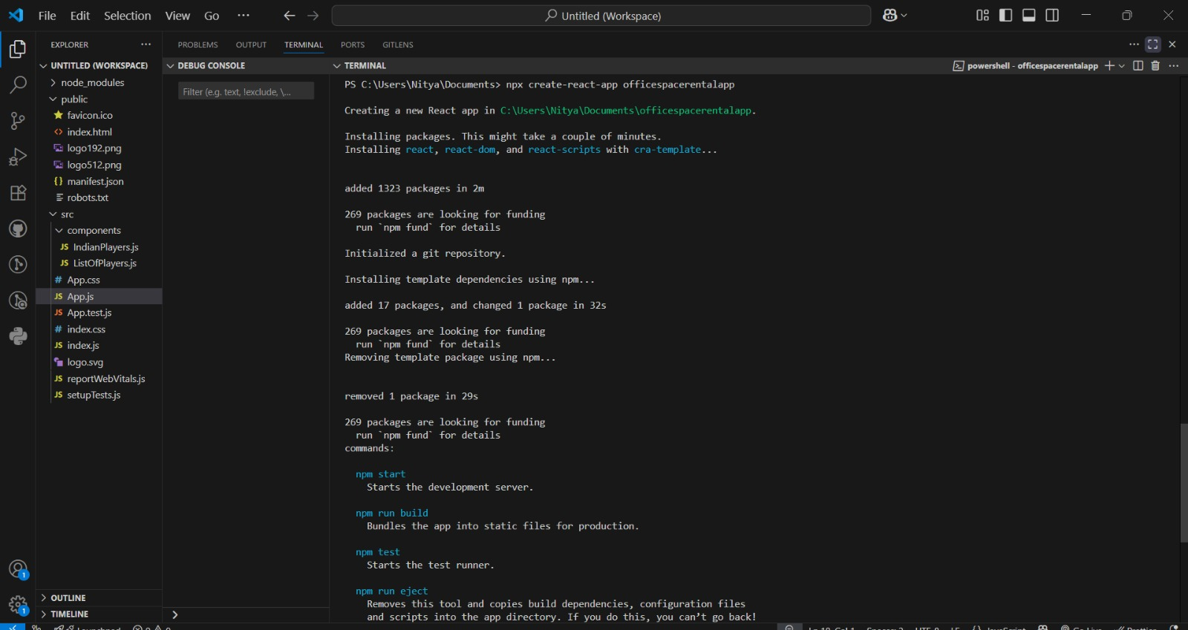
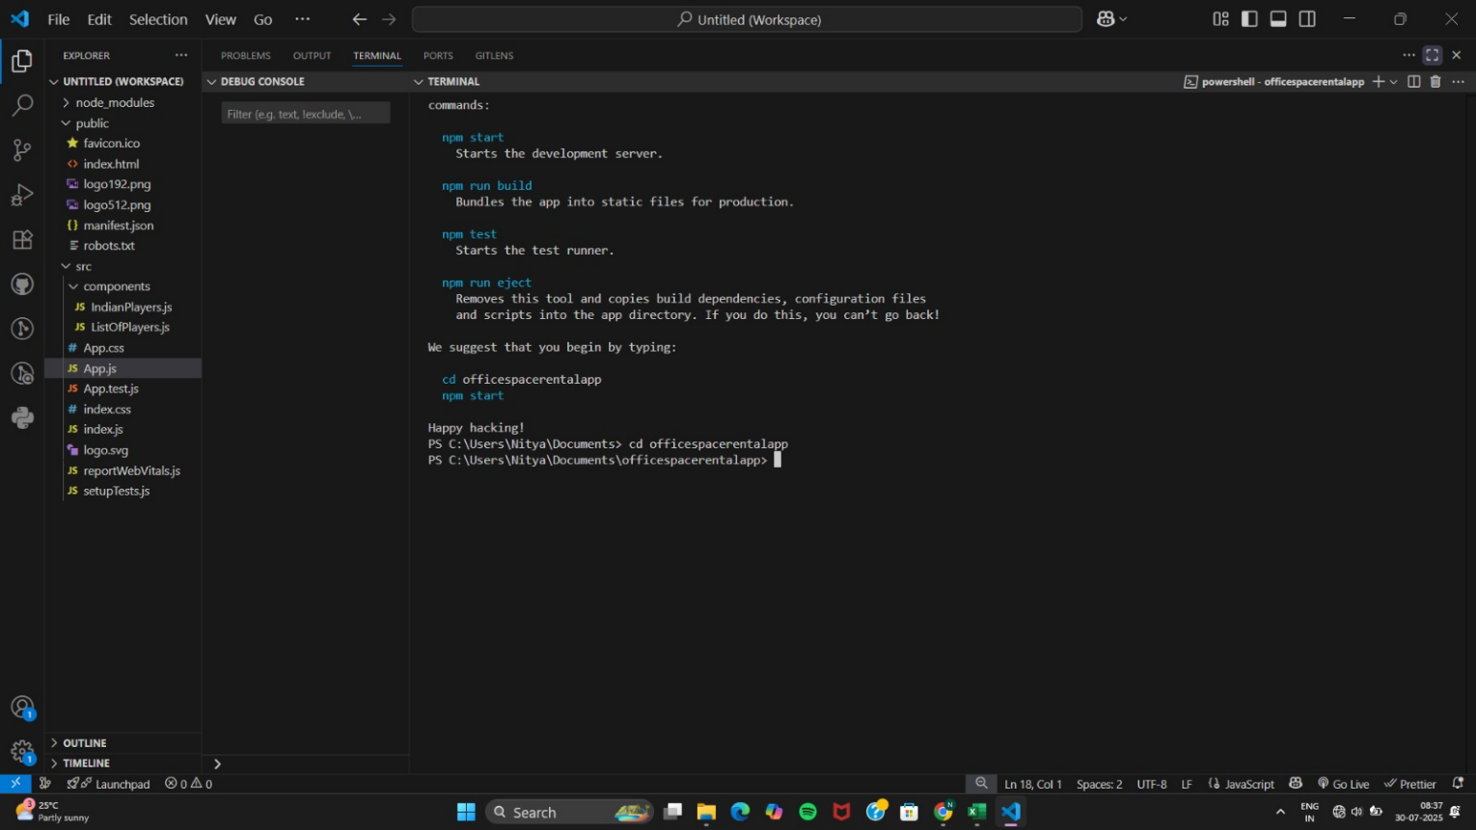
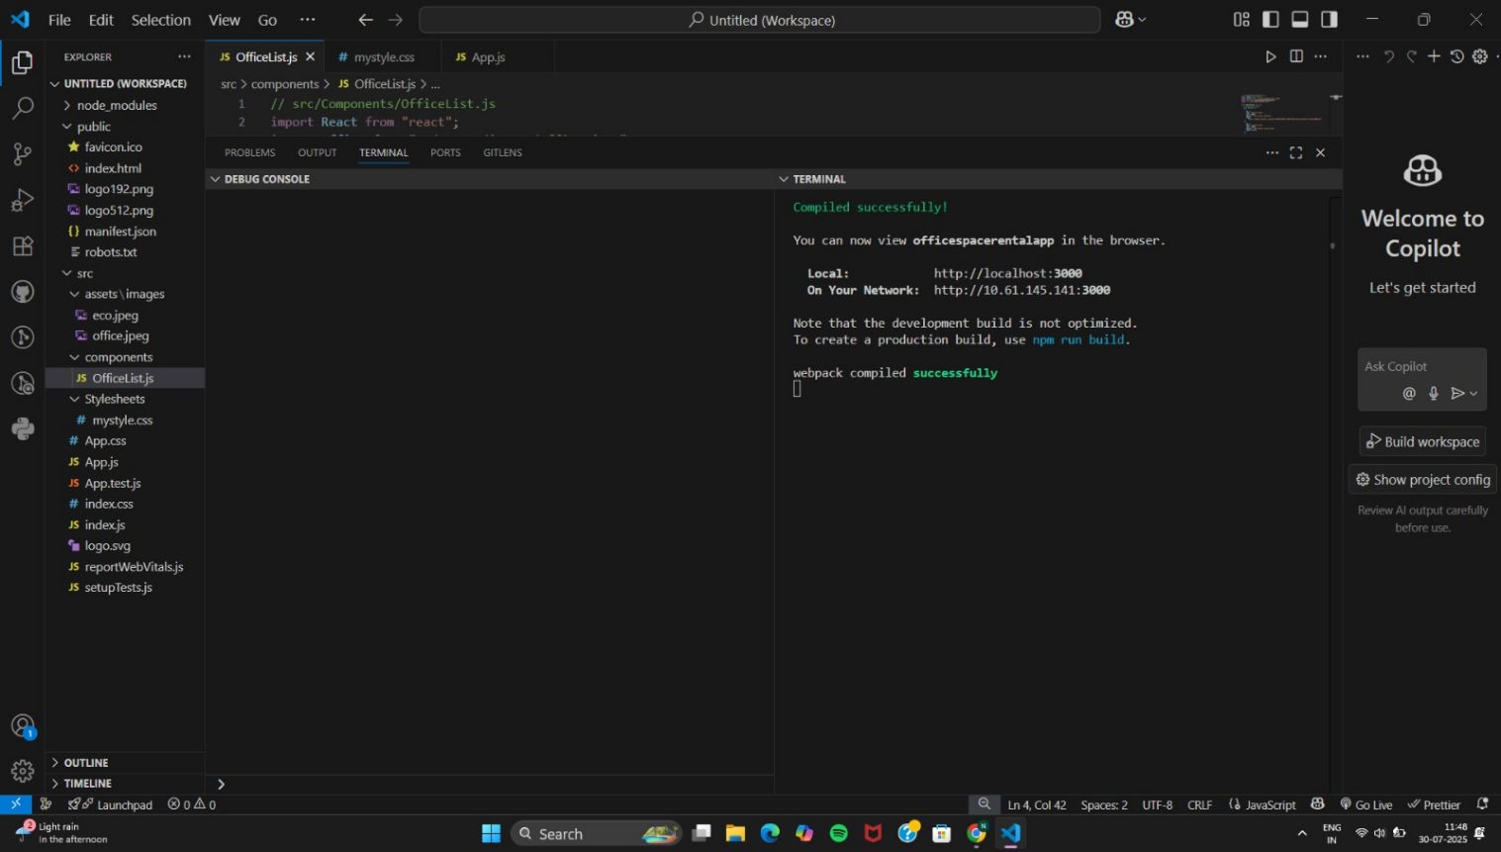

http://localhost:3000
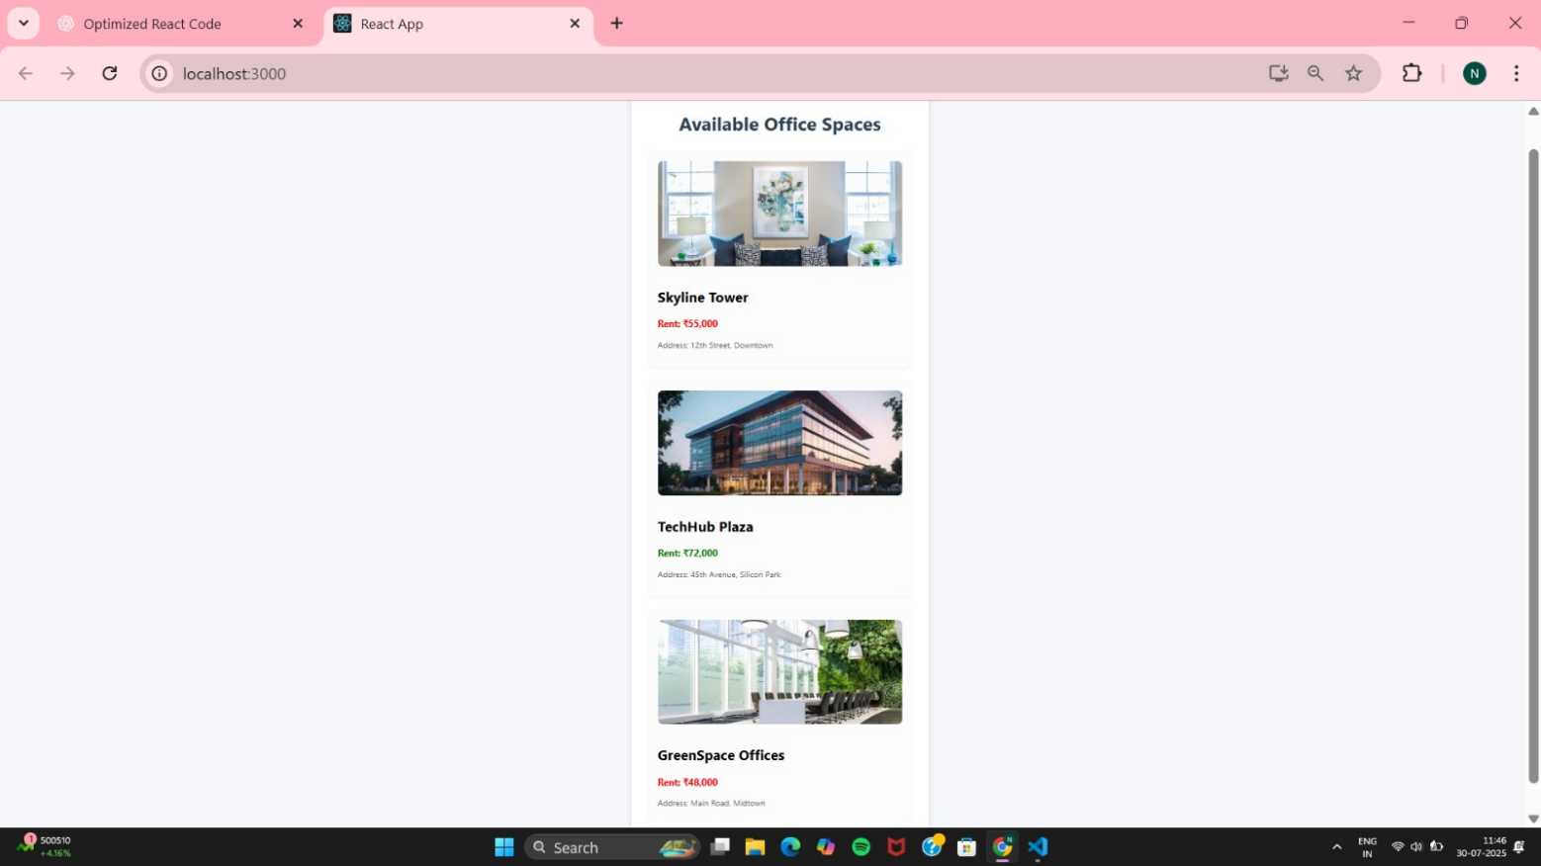

11.ReactJS-HOL
React Application “eventexamplesapp” to handle various events of the form elements in HTML.
(i)Project setup
npx create-react-app eventexamplesapp
cd eventexamplesapp
(ii)Folder structure
src/
├── Components/
│ ├── Counter.js
│ ├── CurrencyConvertor.js
├── App.js
├── Stylesheets/
│ └── mystyle.css
Counter.js
// src/Components/Counter.js
import React, { Component } from "react";
import "../Stylesheets/mystyle.css";
class Counter extends Component {
constructor(props) {
super(props);
this.state = {
count: 0,
};
// Binding method for using 'this'
this.handleDecrement = this.handleDecrement.bind(this);
}
// Method 1: Arrow function
handleIncrement = () => {
this.setState((prevState) => ({ count: prevState.count + 1 }));
this.sayHello();
};
// Method 2: Normal function (manual binding)
handleDecrement() {
this.setState((prevState) => ({ count: prevState.count - 1 }));
}
// Method called within another event
sayHello = () => {
console.log("Hello! Have a great day 🙂");
};
// welcome function
sayWelcome(message) {
alert(`Welcome message: ${message}`);
}
// Synthetic event
handleClick = (event) => {
alert("I was clicked (Synthetic Event)");
console.log("Synthetic Event Type:", event.type);
};
render() {
return (
<div style={{ marginBottom: "40px" }}>
<h2>Counter Example</h2>
<p>Count: {this.state.count}</p>
<button onClick={this.handleIncrement}>Increment</button>
<button onClick={this.handleDecrement}>Decrement</button>
<br />
<button onClick={() => this.sayWelcome("Welcome to React Events!")}>
Say Welcome
</button>
<br />
<button onClick={this.handleClick}>Synthetic Event</button>
</div>
);
}
}
export default Counter;

CurrencyConvertor.js
// src/Components/CurrencyConvertor.js
import React, { useState } from "react";
import "../Stylesheets/mystyle.css";
const CurrencyConvertor = () => {
const [rupees, setRupees] = useState("");
const [euros, setEuros] = useState("");
const handleSubmit = (e) => {
e.preventDefault();
const rupeesNum = parseFloat(rupees);
if (isNaN(rupeesNum)) {
alert("Please enter a valid number.");
return;
}
const converted = rupeesNum * 0.00991; // Example conversion rate
setEuros(converted.toFixed(2));
};
return (
<div>
<h2>Currency Convertor</h2>
<form onSubmit={handleSubmit}>
<input
type="text"
placeholder="Enter amount in ₹ INR"
value={rupees}
onChange={(e) => setRupees(e.target.value)}
/>
<button type="submit">Convert</button>
</form>
{euros && (
<p>
Converted Amount in € Euro: <strong>{euros}</strong>
</p>
)}
</div>
);
};
export default CurrencyConvertor;
App.js
// src/App.js
import "../Stylesheets/mystyle.css";
import React from "react";
import Counter from "./Components/Counter";
import CurrencyConvertor from "./Components/CurrencyConvertor";
function App() {
return (
<div style={{ padding: "30px", fontFamily: "Segoe UI" }}>
<h1>React Event Handling Examples</h1>
<Counter />
<CurrencyConvertor />
</div>
);
}
export default App;
mystyle.css
/* src/Stylesheets/mystyle.css */
button {
margin: 5px;
padding: 8px 14px;
background: #4caf50;
color: white;
border: none;
border-radius: 6px;
cursor: pointer;
}
input {
padding: 6px;
margin-right: 10px;
border-radius: 4px;
border: 1px solid #ccc;
}
(iii)Run the app
Npm start
OUTPUT:
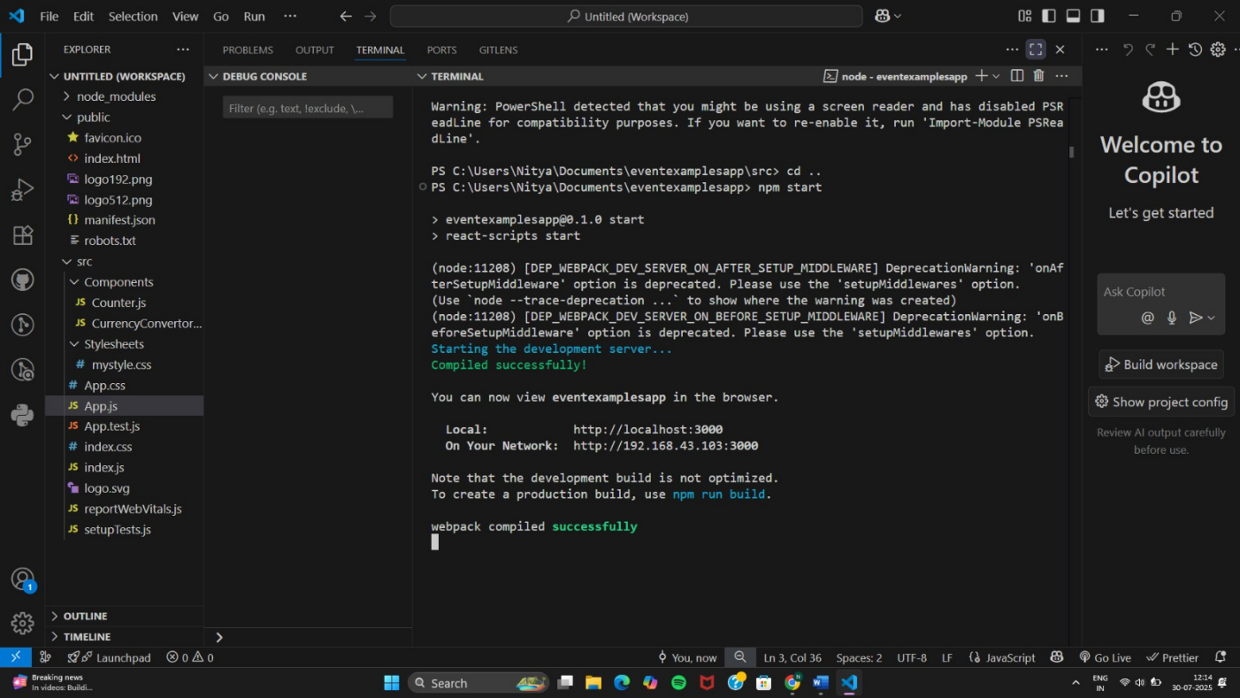

http://localhost:3000
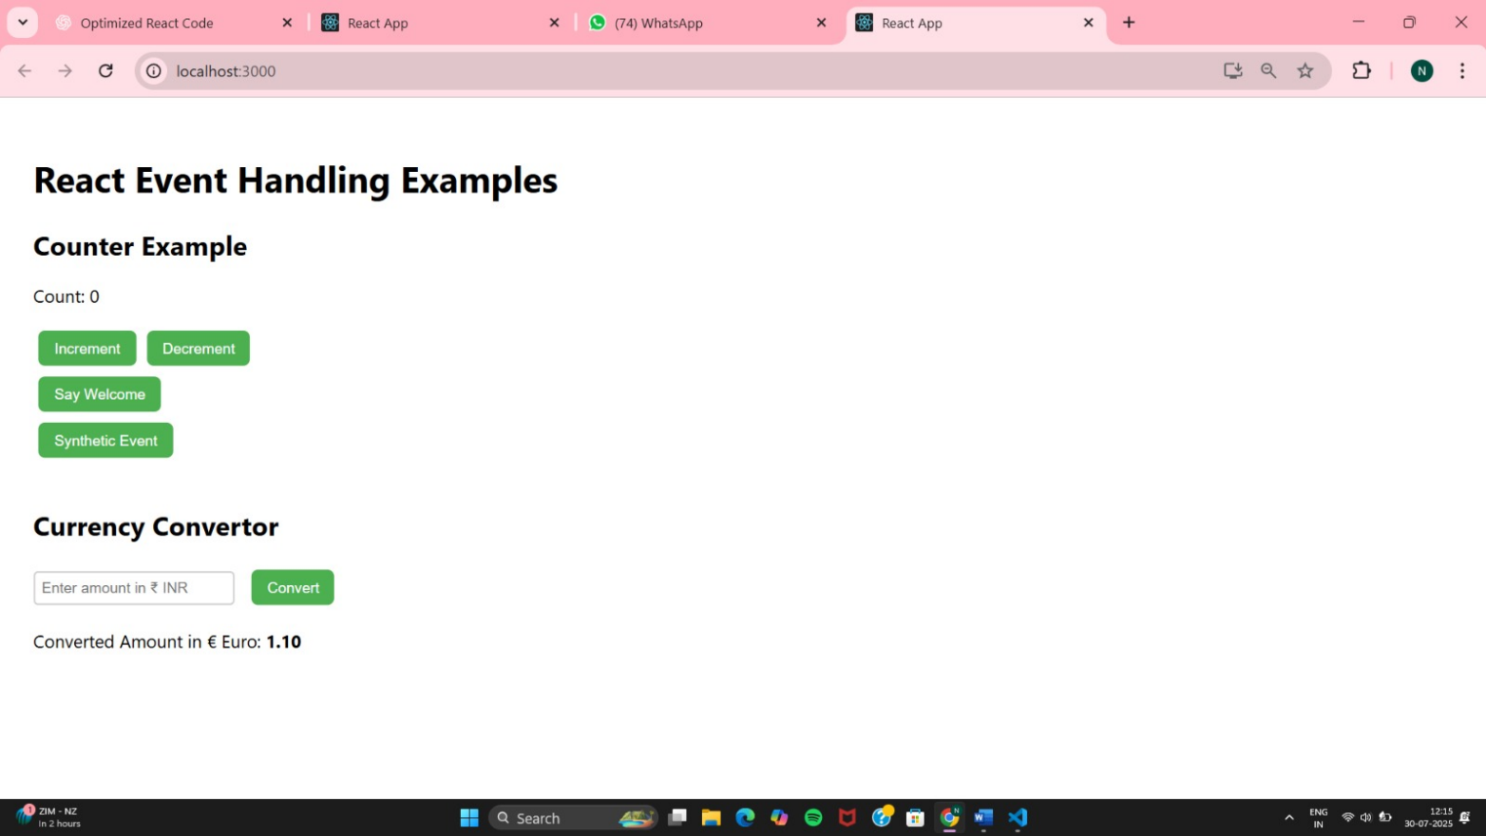

Converter and Increment
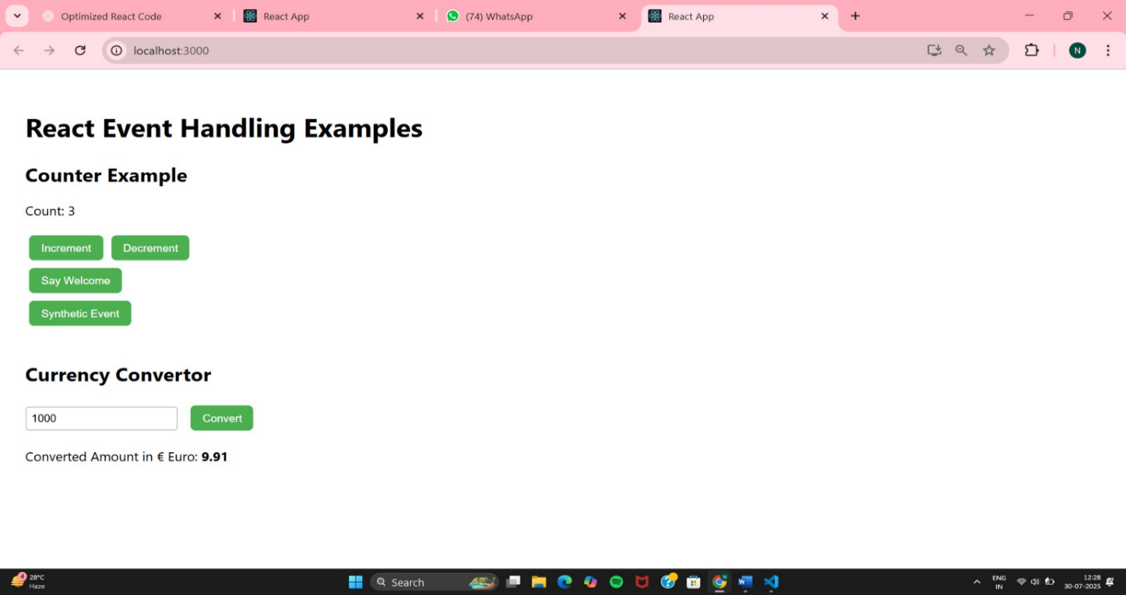

Decrement
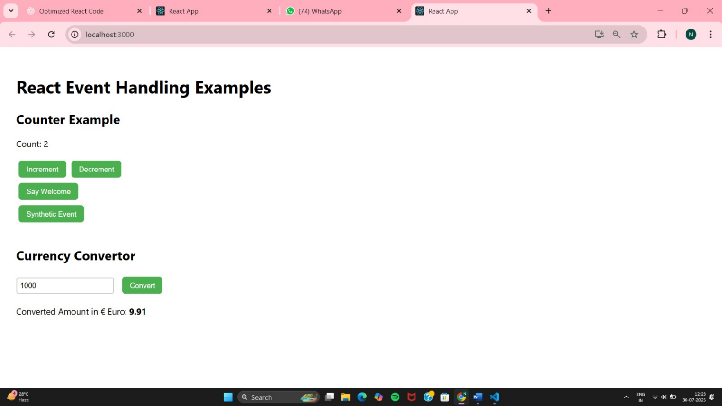
Say Welcome
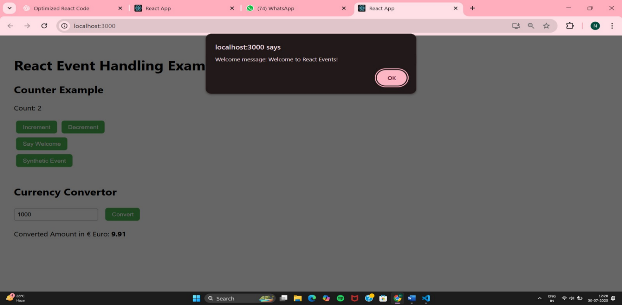
Synthetic Event
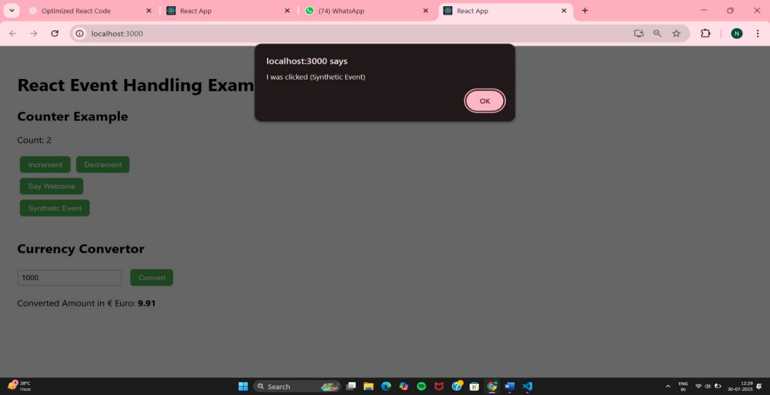

12.ReactJS HOL
Create a React Application named “ticketbookingapp” where the guest user can browse the page where the flight details are displayed whereas the logged in user only can book tickets.
(i)Project setup
npx create-react-app ticketbookingapp
cd ticketbookingapp
(ii)Folder structure
src/
├── Components/
│ ├── GuestPage.js
│ ├── UserPage.js
│ ├── Header.js
├── App.js
├── Stylesheets/
│ └── mystyle.css

GuestPage.js
import React from "react";
const GuestPage = () => {
return (
<div className="page guest">
<h2>Welcome, Guest ✈️</h2>
<p>Please log in to book your flight tickets.</p>
<h3>Available Flights</h3>
<ul>
<li>Hyderabad → Delhi | 08:00 AM</li>
<li>Mumbai → Bangalore | 11:45 AM</li>
<li>Chennai → Kolkata | 04:30 PM</li>
</ul>
</div>
);
};
export default GuestPage;

UserPage.js
import React from "react";
const UserPage = () => {
return (
<div className="page user">
<h2>Welcome Back, User 👤</h2>
<p>You can now book your tickets.</p>
<h3>Book Your Ticket</h3>
<ul>
<li>Hyderabad → Delhi | ₹4,500 <button>Book</button></li>
<li>Mumbai → Bangalore | ₹3,800 <button>Book</button></li>
<li>Chennai → Kolkata | ₹5,200 <button>Book</button></li>
</ul>
</div>
);
};
export default UserPage;

Header.js
// src/Components/Header.js
import React from "react";
const Header = ({ isLoggedIn, onLoginToggle }) => {
return (
<div className="header">
<h1>🛫 Ticket Booking Portal</h1>
<button onClick={onLoginToggle}>
{isLoggedIn ? "Logout" : "Login"}
</button>
</div>
);
};
export default Header;

App.js
// src/App.js
import React, { useState } from "react";
import GuestPage from "./Components/GuestPage";
import UserPage from "./Components/UserPage";
import Header from "./Components/Header";
import "./Stylesheets/mystyle.css";
function App() {
const [isLoggedIn, setIsLoggedIn] = useState(false);
const handleLoginToggle = () => {
setIsLoggedIn((prev) => !prev);
};
return (
<div className="app-container">
<Header isLoggedIn={isLoggedIn} onLoginToggle={handleLoginToggle} />
{isLoggedIn ? <UserPage /> : <GuestPage />}
</div>
);
}
export default App;

mystyle.css
/* src/Stylesheets/mystyle.css */
body {
margin: 0;
font-family: "Segoe UI", Tahoma, sans-serif;
background-color: #f4f8fc;
}
.app-container {
max-width: 800px;
margin: 30px auto;
background: white;
padding: 30px;
border-radius: 12px;
box-shadow: 0 4px 14px rgba(0, 0, 0, 0.1);
}
.header {
display: flex;
justify-content: space-between;
align-items: center;
margin-bottom: 30px;
}
button {
padding: 10px 16px;
border: none;
background-color: #007bff;
color: white;
font-weight: bold;
border-radius: 6px;
cursor: pointer;
}
button:hover {
background-color: #0056b3;
}
.page {
padding: 10px;
}
ul {
list-style: none;
padding: 0;
}
li {
margin: 10px 0;
}
.user li {
display: flex;
justify-content: space-between;
align-items: center;
}

(iii)Run the app
npm start

OUTPUT:
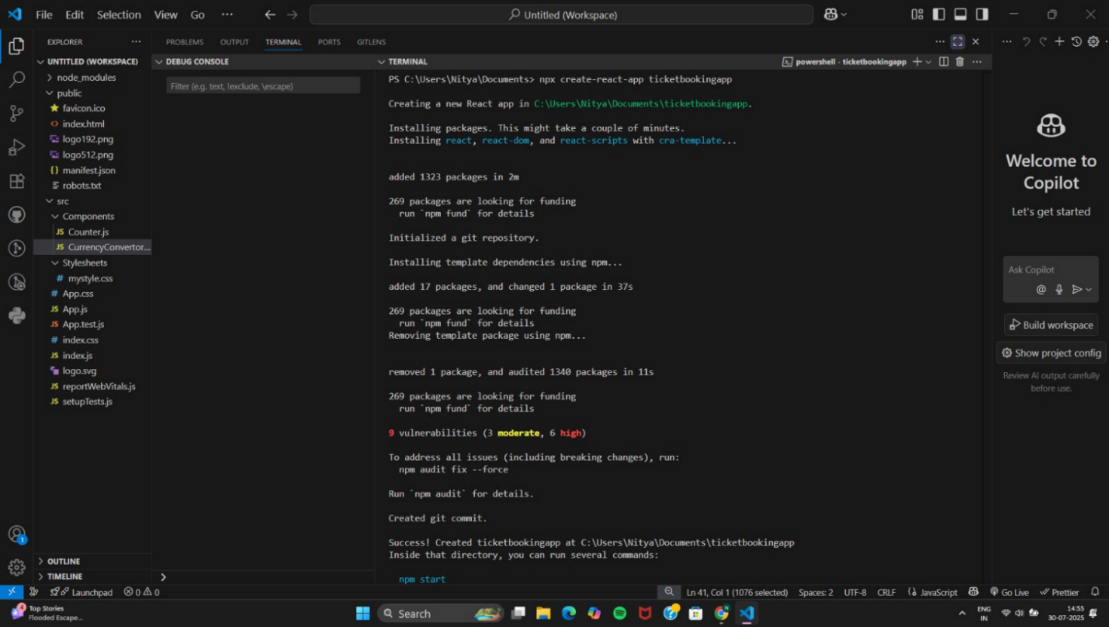
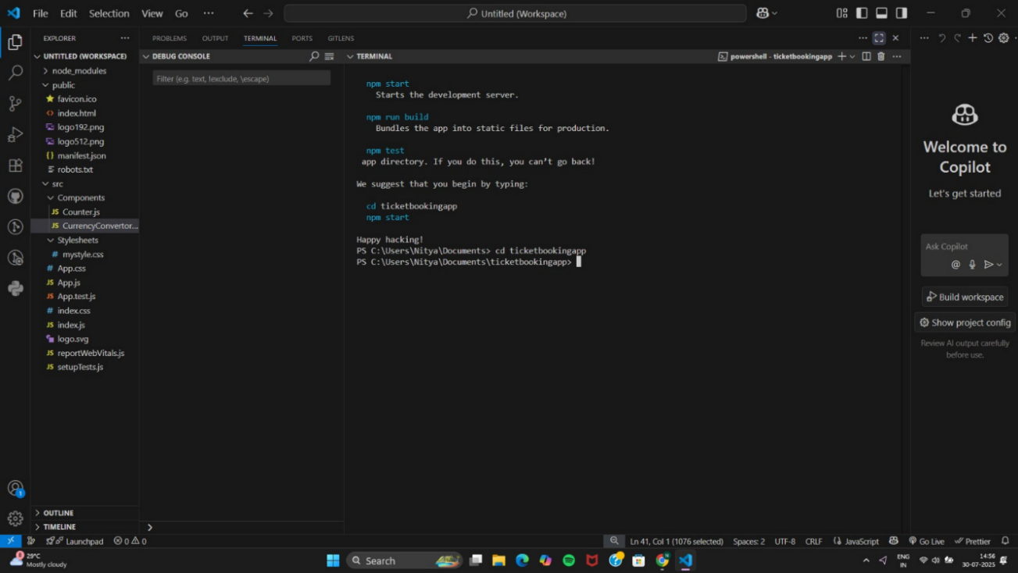

http://localhost:3000
Login page
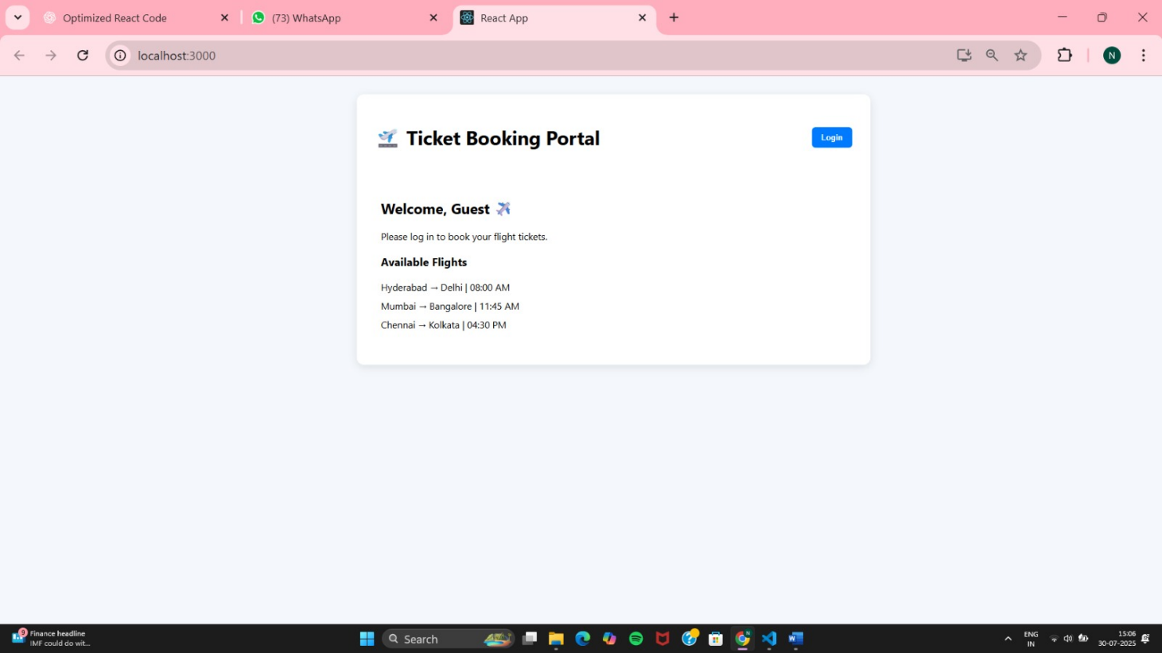

After Login
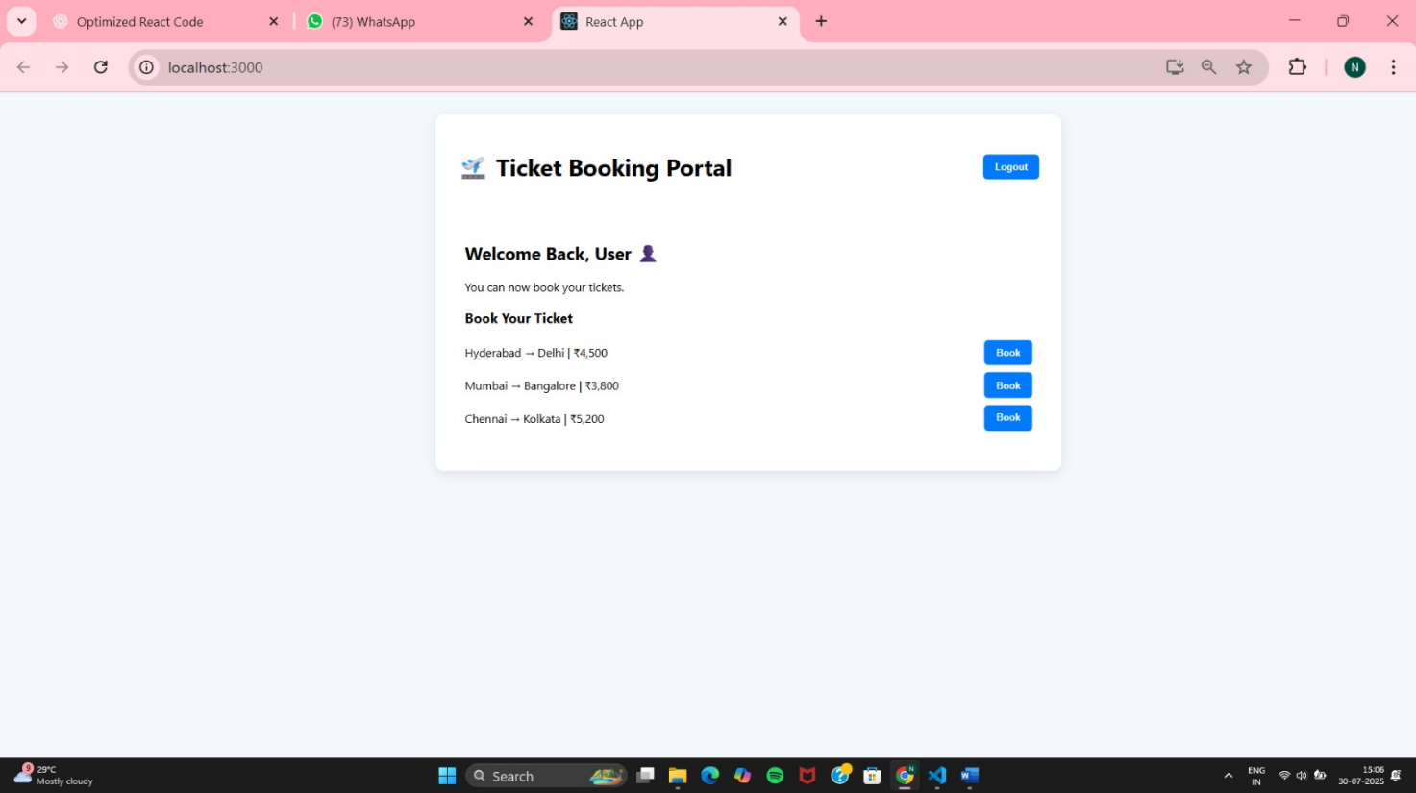
When clicked on logout , the Guest page is displayed.
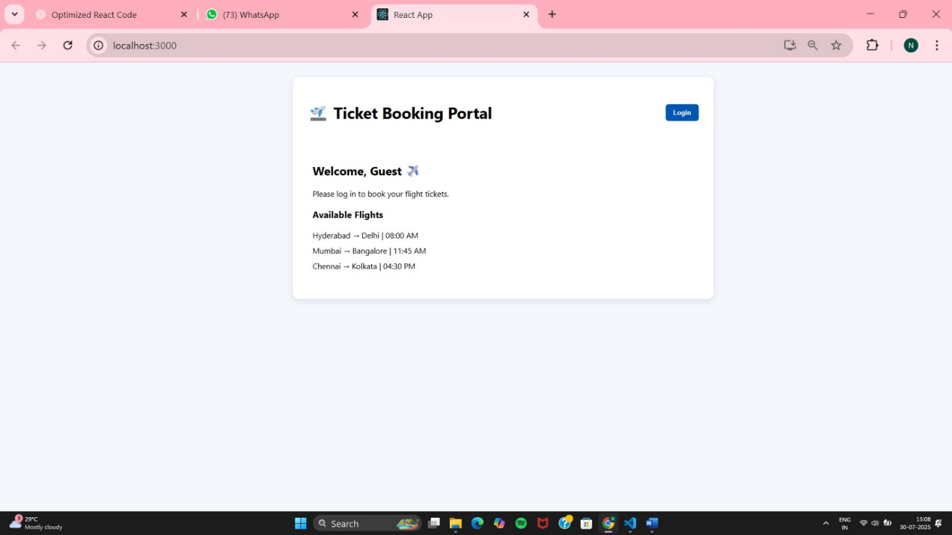

13.ReactJS-HOL
React App named “bloggerapp” in with 3 components.
- Book Details
- Blog Details
- Course Details
(i)Project setup
npx create-react-app bloggerapp
cd bloggerapp
(ii)Folder structure
src/
├── Components/
│ ├── BookDetails.js
│ ├── BlogDetails.js
│ ├── CourseDetails.js
│ └── Tabs.js
├── App.js
└── Stylesheets/
└── mystyle.css
BookDetails.js
// src/Components/BookDetails.js
import React from "react";
const books = [
{ id: 1, title: "Atomic Habits", author: "James Clear" },
{ id: 2, title: "Deep Work", author: "Cal Newport" },
{ id: 3, title: "The Alchemist", author: "Paulo Coelho" },
];
const BookDetails = () => (
<div>
<h2>📚 Book Details</h2>
<ul>
{books.map((book) => (
<li key={book.id}>
<strong>{book.title}</strong> — {book.author}
</li>
))}
</ul>
</div>
);
export default BookDetails;
BlogDetails.js
// src/Components/BlogDetails.js
import React from "react";
const blogs = [
{ id: 1, title: "React Tips", author: "Alex" },
{ id: 2, title: "JS for Beginners", author: "Sara" },
{ id: 3, title: "CSS Mastery", author: "John" },
];
const BlogDetails = () => (
<div>
<h2>📝 Blog Details</h2>
<ul>
{blogs.map((blog) => (
<li key={blog.id}>
<strong>{blog.title}</strong> by {blog.author}
</li>
))}
</ul>
</div>
);
export default BlogDetails;
CourseDetails.js
// src/Components/CourseDetails.js
import React from "react";
const courses = [
{ id: 1, name: "React", duration: "6 weeks" },
{ id: 2, name: "Node.js", duration: "4 weeks" },
{ id: 3, name: "Python", duration: "8 weeks" },
];
const CourseDetails = () => (
<div>
<h2>🎓 Course Details</h2>
<ul>
{courses.map((course) => (
<li key={course.id}>
{course.name} — {course.duration}
</li>
))}
</ul>
</div>
);
export default CourseDetails;
Tabs.js
// src/Components/Tabs.js
import React, { useState } from "react";
import BookDetails from "./BookDetails";
import BlogDetails from "./BlogDetails";
import CourseDetails from "./CourseDetails";
const Tabs = () => {
const [activeTab, setActiveTab] = useState("books");
const renderComponent = () => {
switch (activeTab) {
case "books":
return <BookDetails />;
case "blogs":
return <BlogDetails />;
case "courses":
return <CourseDetails />;
default:
return <BookDetails />;
}
};
return (
<div>
<div className="tab-buttons">
<button onClick={() => setActiveTab("books")}>Books</button>
<button onClick={() => setActiveTab("blogs")}>Blogs</button>
<button onClick={() => setActiveTab("courses")}>Courses</button>
</div>
<div className="tab-content">{renderComponent()}</div>
</div>
);
};
export default Tabs;
App.js
// src/App.js
import React from "react";
import Tabs from "./Components/Tabs";
import "./Stylesheets/mystyle.css";
function App() {
return (
<div className="app-container">
<h1>📘 Blogger App</h1>
<Tabs />
</div>
);
}
export default App;

mystyle.css
body {
font-family: "Segoe UI", sans-serif;
background-color: #f8f9fa;
padding: 30px;
}
.app-container {
background: white;
padding: 25px;
border-radius: 8px;
max-width: 700px;
margin: auto;
box-shadow: 0 4px 14px rgba(0, 0, 0, 0.1);
}
.tab-buttons {
margin-bottom: 20px;
}
button {
padding: 10px 16px;
margin-right: 10px;
background-color: #007bff;
border: none;
color: white;
border-radius: 6px;
cursor: pointer;
}
button:hover {
background-color: #0056b3;
}
ul {
list-style: none;
padding: 0;
}
li {
margin-bottom: 10px;
}

(iii)Start the app
npm start

OUTPUT:
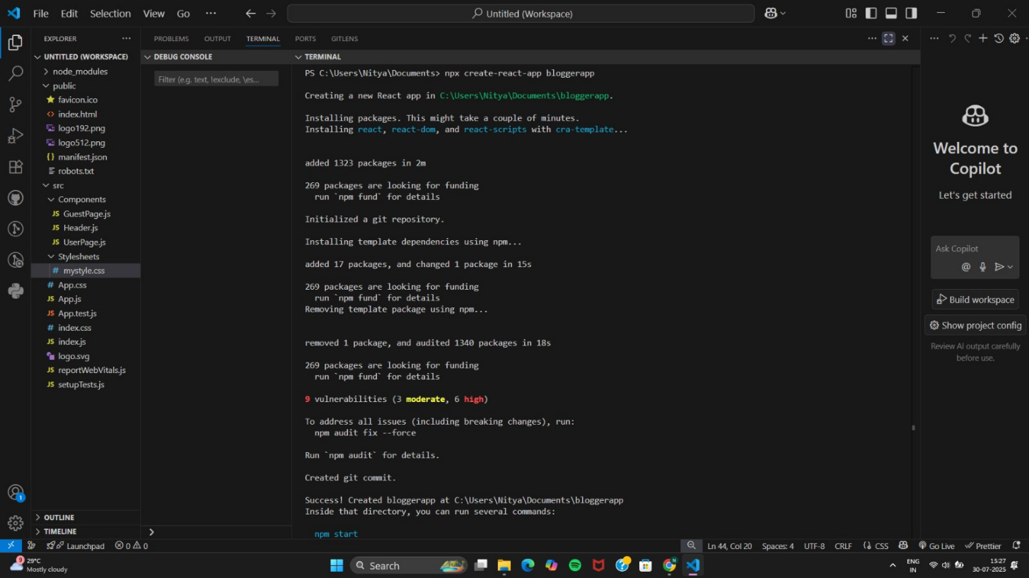
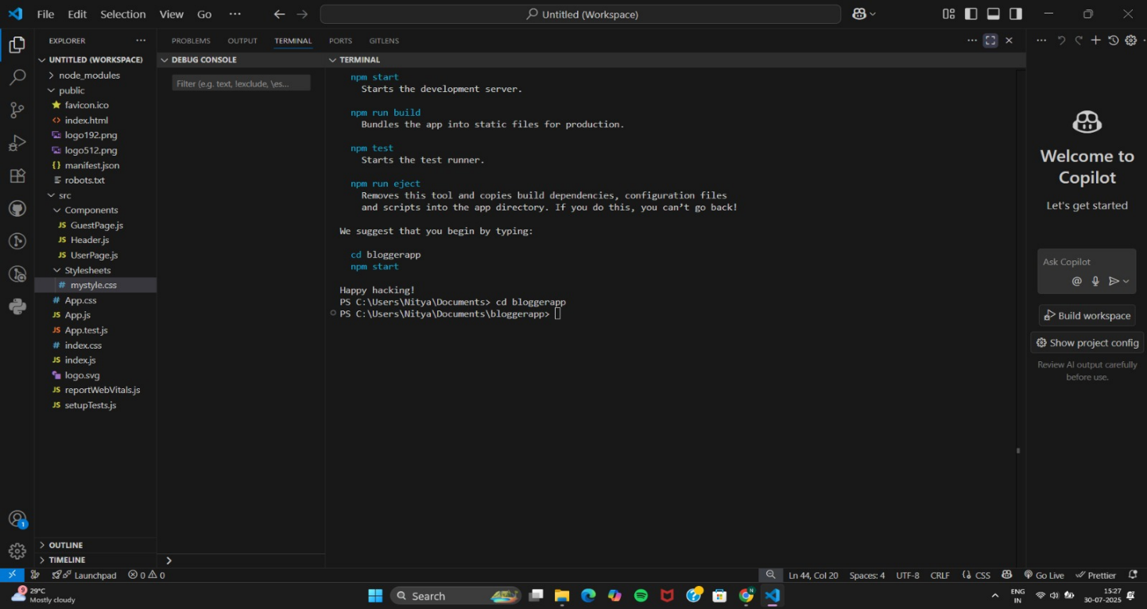
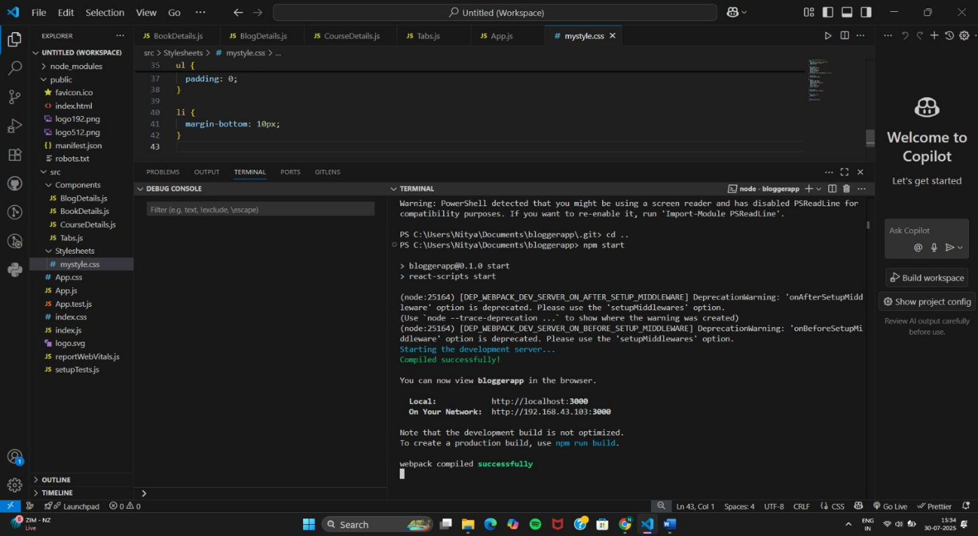
Book Details
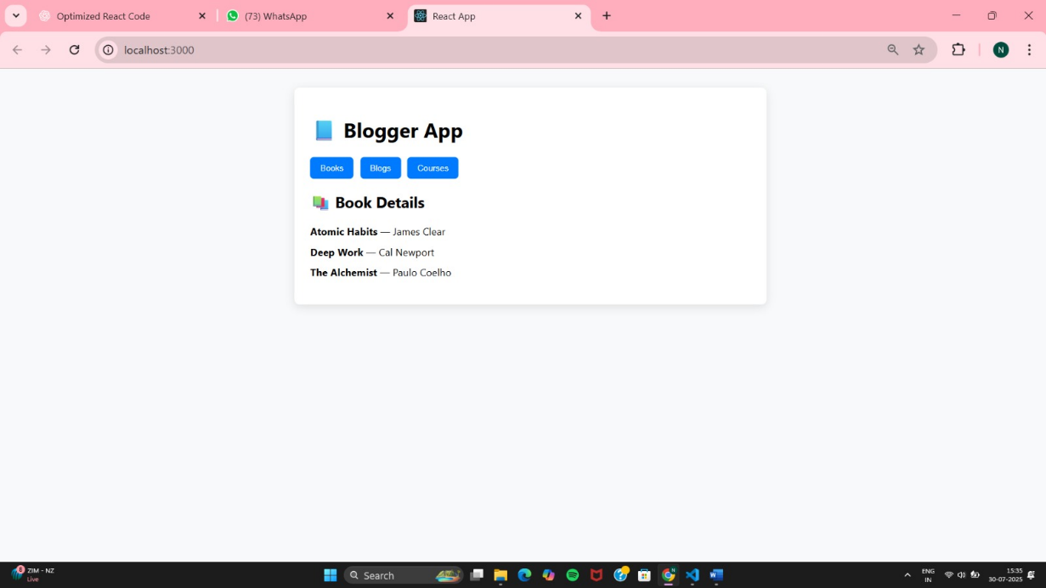
Blog Details
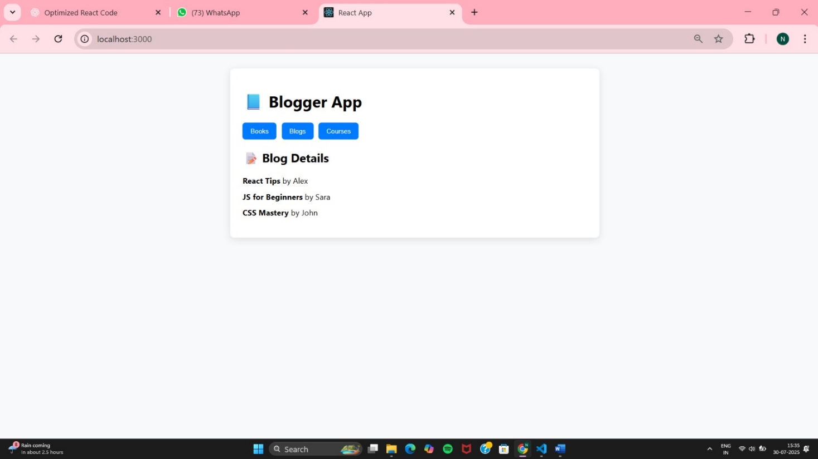

Course Details
